Money and Budget

Money talks - / under the counter/

Personal finance:

- thrifty / tight-fisted/ deny yourself to

wasteful/ spend money like water/ treat yourself to

- squander / put aside for a rainy day

- expenditures under supervision/ keep books



- shortages of / deficient in/live below breadline

- beforehand / spontaneously

-heavily indebted/ run into debt / fall behind with instalments

Wealthy/poverty-stricken

**Live o……………….**

He **live s**o…………………providing plumber services

**Well-b…………………….**

My well-b……………………..depends on myself

**……………………charge**

They have ……………………….me for that entrance ticket. It is ridiculously expansive

**Well-……………….. / move in the circle of /warm your way into**

A lot of young people are w……………….. nowadays. They made money in intimidating pace

**Make e………………………meet**

They can hardly make e……………………….meet

**p……………….**

I always go for p…………………..products

**Rip………………..**

It was a total ……………………. I had to spend twice more than usual

**p…………………..**

Every month some of my p……………………go to National Insurance company

**R………………………….**

My r…………………………..is average

**……………………..of cash**

I am …………………of cash right now

**Interest b………………………**

Interest b………………………of that loan is massive

**Credit r…………………..**

He doesn’t have credit r…………………..that’s why he will not receive long-term loan

**i…………………….**

He has to pay high i……………………….every single month due to frank’s fluctuations and instability

**d……………………**

Judge decided to d……………………..his debt as he was insolvent

**o…………………**

He **o…………………**me significant amount of money

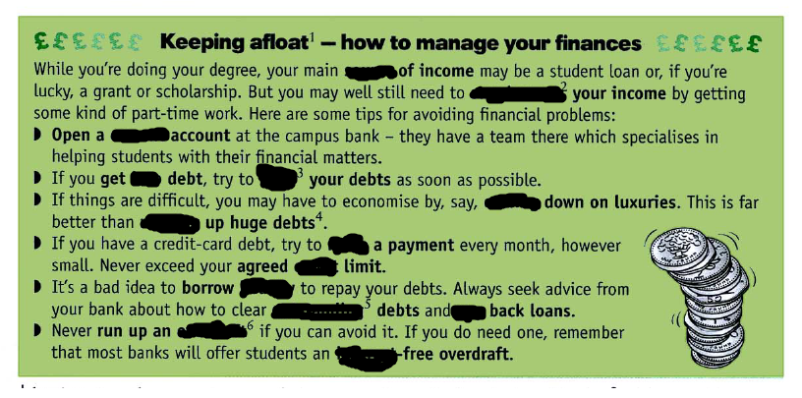

**source, clear, running , into , cutting , outstanding, interest, overdraft, make, supplement, heavily, credit, pay , into**

-invest –shares , securities/return on investment

Cash it on

Capitalize on

Prosperous business / thriving

The ownersdecided to sell the soccer team in order to cuttheirlosses.

Products

Prefix : priced , rated , sufficient , foreseen, react ,

Verbs: overcome , surpass , arise/ spark , boost , allocate

Adjective : daunting , promising , exorbitant , affordable , viable , feasible , abundant in, seductive, disruptive, unanimous, perilous

Phrases : last resort, knock on effect , boil down to ,